01.
class Example1{
public static void main(String args[]) {
System.out.println("Institute of Computer Engineering Technology");
}
}

Output
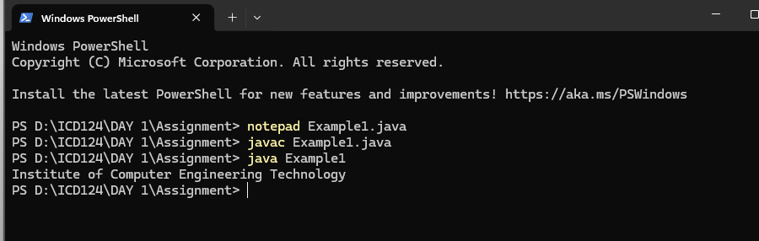

02.
class Example2 {
public static void main(String args[]){
System.out.println("Institute of computer Engineering Technology");
System.out.println("223 A,");
System.out.println("Galle Road,");
System.out.println("Panadura.");
}
}

Output

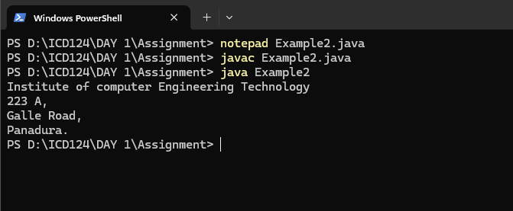
03.
class Example3 {
public static void main (String args[]){
System.out.println("J");
System.out.println("A");
System.out.println("V");
System.out.println("A");
}
}

output
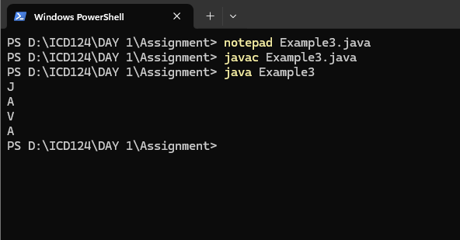

04.
class Example4 {
public static void main(String args[] ){
System.out.println("1");
System.out.println(1000);
System.out.println(1.23);

}
}
Output
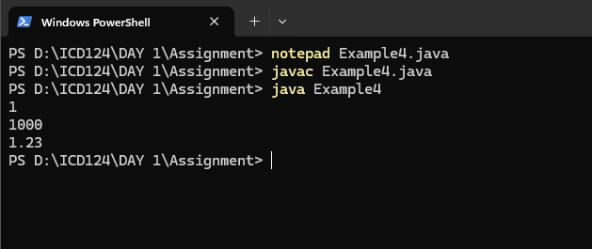

05.
class Example5 {
public static void main(String args[]){
System.out.println("Hello");
System.out.println("A");
System.out.println(1234);
System.out.println(-1234);
System.out.println(1.2334);
System.out.println(0.0032);
System.out.println(-0.0023);
System.out.println('A');
System.out.println('6');
System.out.println(true);
System.out.println(false);
}
}
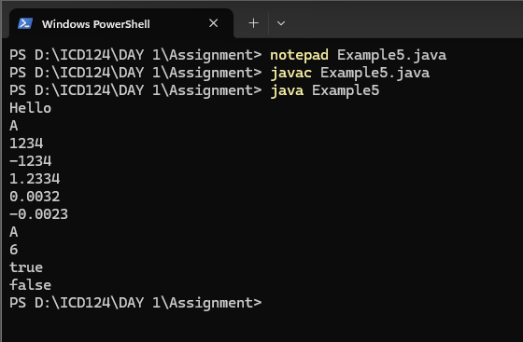
06.
class Example6 {
public static void main(String args[]){
System.out.println("A");
System.out.println("B");
System.out.println("C");
System.out.println("D");
}
}
Output
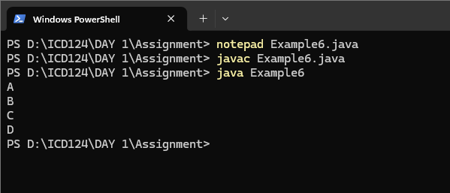

07.
class Example7 {
public static void main (String args[]){
System.out.println("1");
System.out.print("2 ");
System.out.println("3 ");
System.out.print("4 ");
System.out.print("5 ");
System.out.println("6 ");
System.out.print("7 ");
System.out.print("8 ");
System.out.print("9 ");
System.out.println("10 ");
}
}
Output
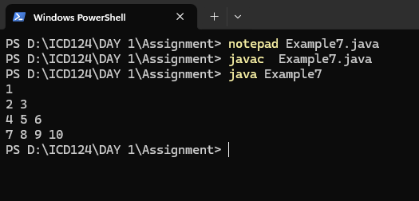
08
class Example8 {
Public static void main(String args[]){
System.out.print("1");
System.out.println();
System.out.print("2 ");
System.out.print("3 ");
System.out.println();
System.out.print("4 ");
System.out.print("5 ");
System.out.print("6 ");
System.out.println();
System.out.print("7 ");
System.out.print("8 ");
System.out.print("9 ");
System.out.print("10 ");
}
}
Output
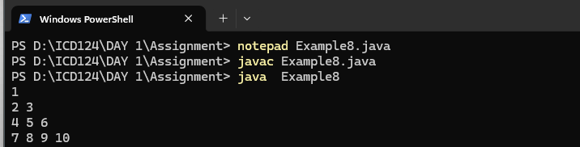
09.
class Example9 {
public static void main(String args[]){
System.out.println("A");
System.out.println("B");
System.out.println();
System.out.println("C");
System.out.println("D");
System.out.print("");
}
}
Output
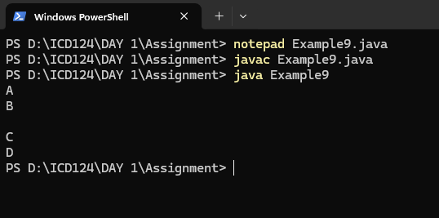

10.
class Example10 {
public static void main(String args[]){
System.out.println("A");
System.out.println("B");
System.out.print();
System.out.println("C");
System.out.println("D");
}
}
Output
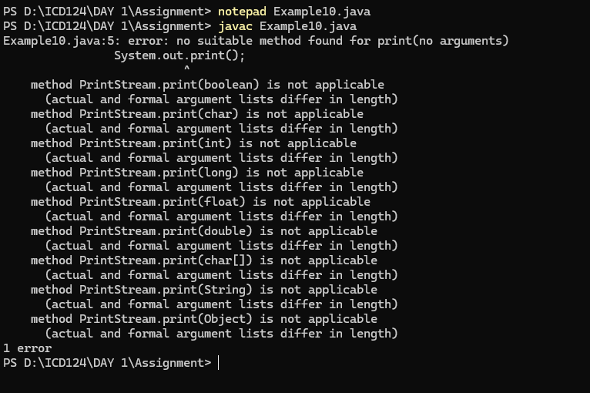
- Error because not double Quats or not println
11.
class Example11 {
public static void main(String args[]){
int a;
a=100;
System.out.println("a");
System.out.println(a);
}
}
Output
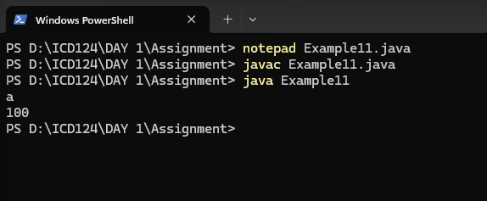

12.
class Example12{
public static void main(String args[]){
int a;
System.out.println("a");
System.out.println(a);
}
}
Output
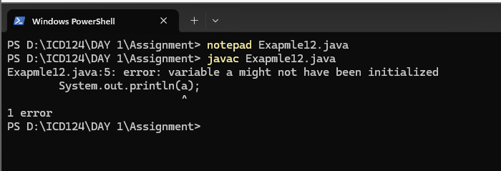
- Error because it doesn’t have an assign a value

13.
class Example13{
public static void main(String args[]){
int a = 100;
System.out.println(a);
}
}
Output
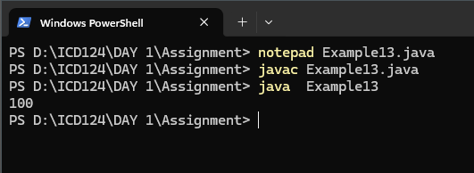

14.
class Example14{
public static void main(String args[]){
int a;
System.out.println(a);
a = 100;
}
}
Output
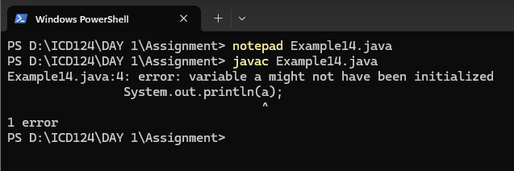
- Error because java executes line by line then it executes without assigning a value

15.
class Example15{
public static void main(String args[]){
int x;
x=100;
x=200;
System.out.println(x);
}
}
Output
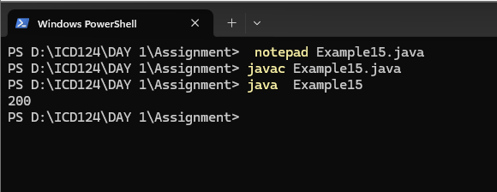

16.
class Example16{
public static void main(String args[]){
int x;
x=100;
System.out.println(x);
x=200;
System.out.println(x);
}
}
Output
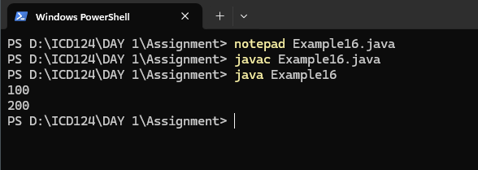

17.
class Example17{
public static void main(String args[]){
int x= 100;
int y =200;
System.out.println(x);
System.out.println(y);
}
}
Output
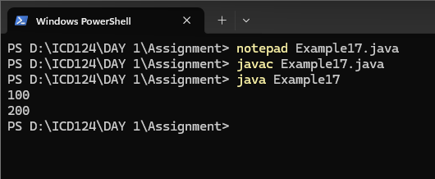

18.
class Example18{
public static void main(String args[]){
int x;
x=1000;
System.out.println(x);
var y =2000;
System.out.println(y);
}
}
Output
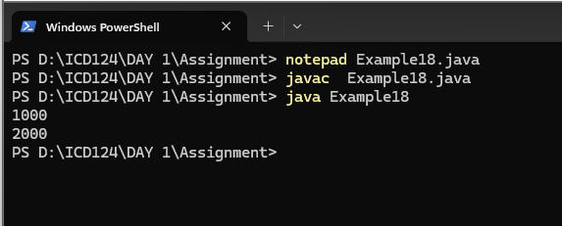

19.
class Example19{
public static void main(String args[]){
int x=100;
int y=200;
int z;
System.out.println(x);
System.out.println(y);
System.out.println(z);
}
}
Output
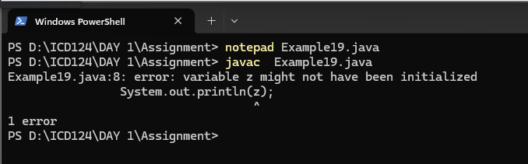
- Error because there is a variable without assigning a value

20.
class Example20{
public static void main(String args[]){
int x = 100,y,z=200;
System.out.println(x);
y="java";
System.out.println(y);
System.out.println(z);
}
}
Output
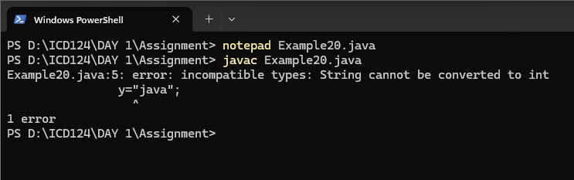
- Error because of invalid typecasting

21.
class Example21{
public static void main(String args[]){
System.out.println("A");
//System.out.println("B");
System.out.println("C");
//System.out.println("D");
System.out.println("E");
}
}
Output
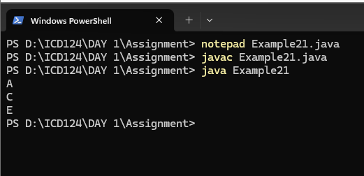

22.
class Example22{
public static void main(String args[]){
System.out.println("A");
System.out.println("B");
/*System.out.println("C");
System.out.println("D");
System.out.println("E");*/
System.out.println("F");

}
}
Output
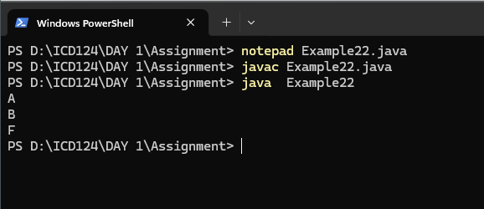

23.
class Example23{
public static void main (String args[]){
int x=100;
int y=200;
System.out.println(x);
System.out.println(y);
x=y;
System.out.println(x);
System.out.println(y);
}
}
Output
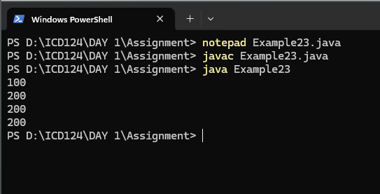

24.
class Example24{
public static void main (String args[]){
System.out.println(true);
System.out.println("true");
}
}
output
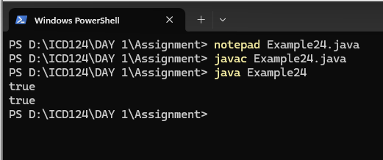

25.
class Example25{
public static void main(String args[]){
System.out.println(Java);
System.out.println("Java");
}
}
Output
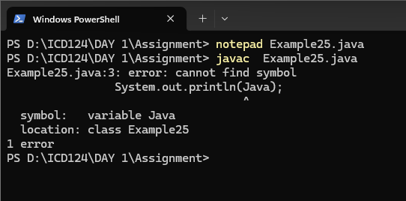
- Error because there is no value assign for that variable

26.
class Example26{
public static void main(String args[]){
System.out.println('A');
System.out.println("A");
System.out.println('2');
System.out.println("2");
System.out.println('JAVA');
System.out.println("JAVA");
}
}
Output
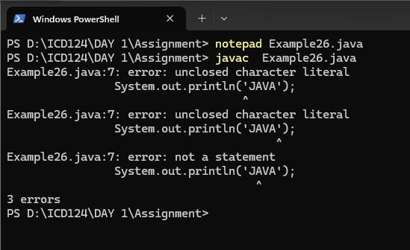
- Error, unclosed character literal
27.
class Example27{
public static void main(String args[]){
System.out.println("Hellooooo\tJAVA");
System.out.println("Hellooooo\t\t\t\tJAVA");
}
}
output
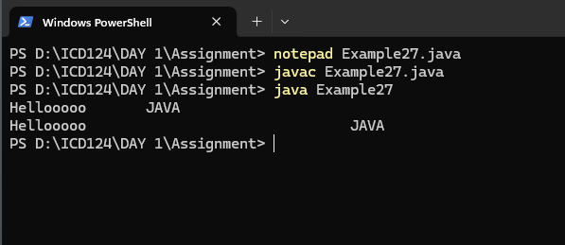

28.
class Example28{
public static void main(String args[]){
System.out.println("Hi\tJAVA");
System.out.println("Hello\tWorld");
}
}
Output
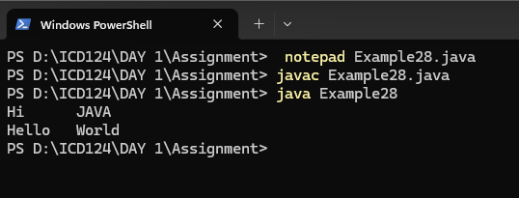

29.
class Example29{
public static void main(String args[]){
System.out.println("AB\nCD");
System.out.println("");
System.out.println("EF\tGH\n\nIJ\tKL");
}
}
output
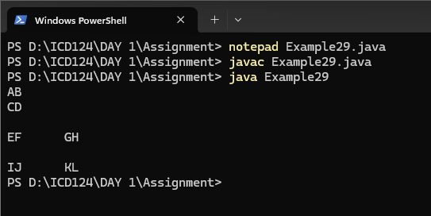

30.
class Example{
public static void main(String args[]){
System.out.println("time - "17:56:02"");
}
}
Output
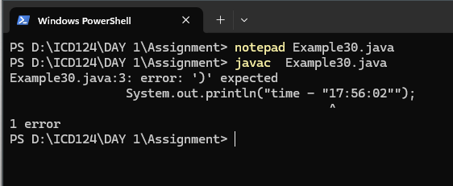
- Error, runtime error.

31.
class Example31{
public static void main(String args[]){
System.out.println("\'iCET\'");
System.out.println("\"Institute of Computer Engineering technology\"");
}
}
Output
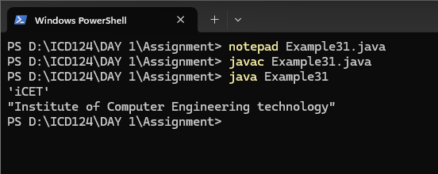

32.
class Example32{
public static void main(String args[]){
System.out.println("first Line \nSecond Line");
System.out.println("A\tB\tC");
System.out.println("D\tE\tF");
}
}
Output
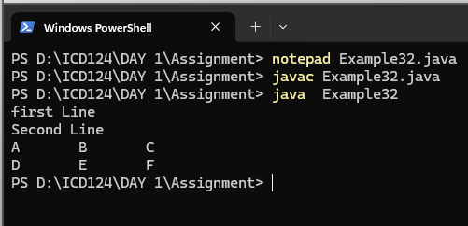

33.
class Example33{
public static void main (String args[]){
System.out.println("AB\nCD");
System.out.println("AB\tCD");
System.out.println("AB\fCD");
System.out.println("AB\bCD");
System.out.println("AB\rCD");
System.out.println("AB\\CD");
}
}
Output
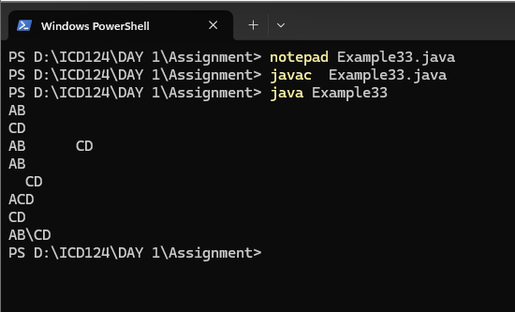

34.
class Example34{
public static void main(String args[]){
System.out.println(10+20);
System.out.println("10"+"20");
System.out.println("10"+20);
System.out.println(10+"20");
}
}
Output
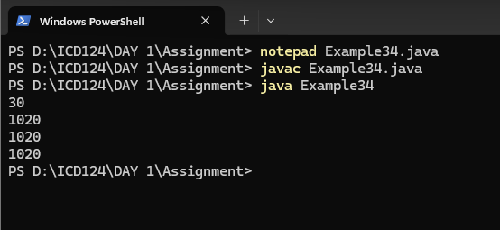

35.
class Example35{
public static void main(String args[]){
System.out.println(20230326);
System.out.println("2023-03-26");
}
}
Output
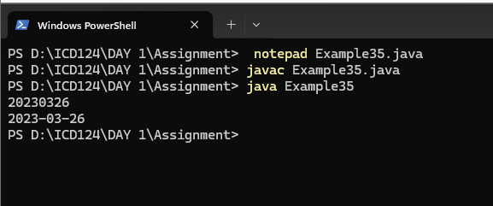

36.
class Example36{
public static void main(String args[]){
int x,y,z;
x =10;
y =20;
z=x+y;
System.out.println(x+"+"+y+"="+z);
}
}
Output
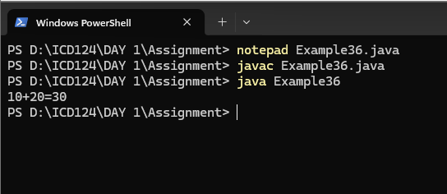

37.
class Example37{
public static void main(String args[]){
int x=10,y=20;
System.out.println(x+y);
System.out.println("x"+"y");
System.out.println("x+y");
System.out.println("x"+y);
System.out.println(x+"y");
}
}
Output
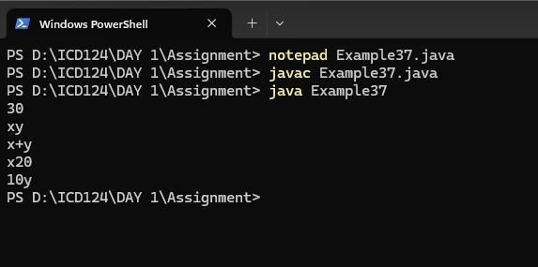

38.
class Example{
public static void main (String args[]){
System.out.println(10+20+30);
System.out.println("10+20+30");
System.out.println(10+20+30);
System.out.println("10+20"+30);
System.out.println("10"+"20"+"30");
System.out.println("10"+20+30);
System.out.println(10+20+"30");
System.out.println(10+"20"+30);
}
}
Output
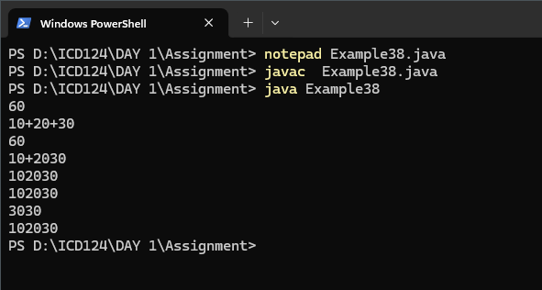
39.
class Example39{
public static void main(String args[]){
String s1="Hello";
System.out.println(s1);
System.out.println(s1.concat("JAVA"));
}
}
Output
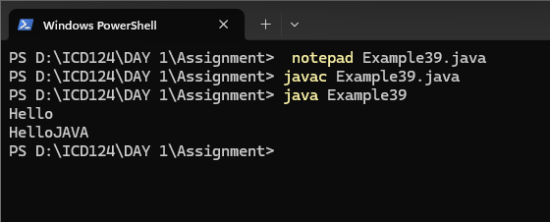

40.
class Example40{
public static void main(String args[]){
int x,y,z;
x=10;
y=20;
z=x+y;
System.out.println(x+"+"+y+"="+z);
z=x-y;
System.out.println(x+"-"+y+"="+z);
z=x*y;
System.out.println(x+"*"+y+"="+z);
}
}
Output
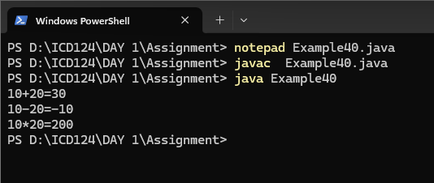

41.
class Example41{
public static void main(String args[]){
int x,y,z;
x=10;
y=20;
System.out.println(x+"+"+y+" = "+(x+y));
System.out.println(x+"-"+y+" = "+(x-y));
System.out.println(x+"*"+y+" = "+(x*y));
}
}
Output
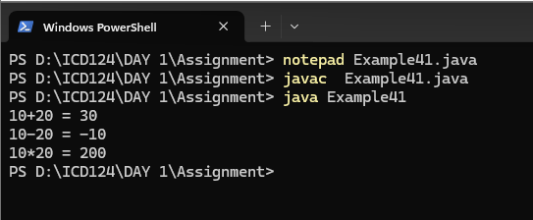

42.
class Example42{
public static void main(String args[]){
int x,y,z;
x=100;
y=200;
System.out.println(x);
System.out.println(y);
y=x;
System.out.println(x);
System.out.println(y);
}
}
Output
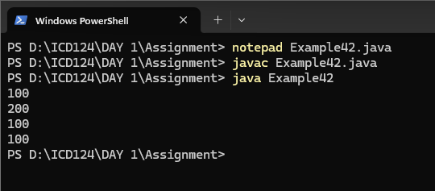

43.
class Example43{
public static void main(String args[]){
int num=103;
if(num>0){
System.out.println(num+" is positive number");
}else if(num<0){
System.out.println(num+" is negative number");
}else{
System.out.println(num+" is 0");
}
}
}
Output
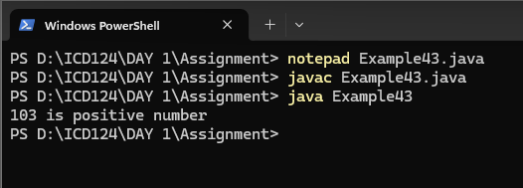

44.
import java.util.*;
class Example44{
public static void main(String args[]){
Scanner input= new Scanner(System.in);
System.out.print("Input number - ");
int num=input.nextInt();
if(num>0){
System.out.println(num+" is positive number");
}else if(num<0){
System.out.println(num+" is negative number");
}else{
System.out.println(num+" is 0");
}
}
}
Output
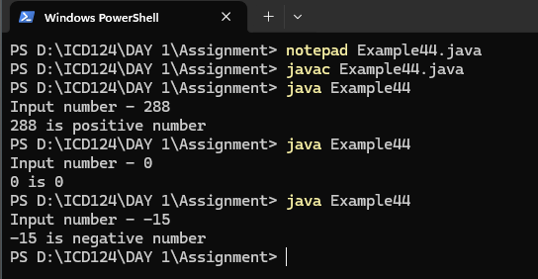
45.
import java.util.*;
class Example45{
public static void main(String args[]){
Scanner input=new Scanner(System.in);
System.out.print("Enter your mark - ");
int mark=input.nextInt();
if(mark>=75){
System.out.println("your grade is A");
}else if(mark>=65){
System.out.println("your grade is B");
}else if(mark>=50){
System.out.println("your grade is C");
}else{
System.out.println("your grade is F");
}
}
}
Output
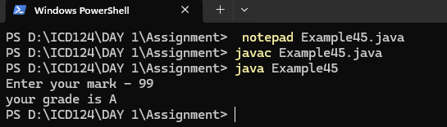
46.
import java.util.*;
class Example46{
public static void main(String args[]){
Scanner input=new Scanner(System.in);
System.out.print("Enter Your age - ");
int age=input.nextInt();
if(age<18){
System.out.println("age is not valid for vote");
}else{
System.out.println("welcome to vote");
}
}
}
Output
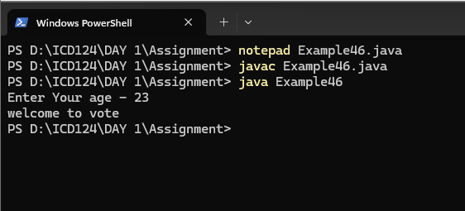
47.
class Example47{
public static void main (String args[]){
double x,y,z;
x=3;
y=4;
z=Math.sqrt(x*x+y*y);
System.out.println("Hypotenuse is "+z);
}
}
Output
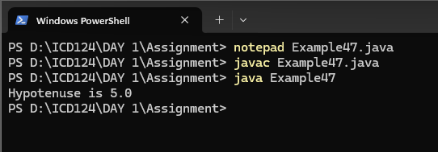

48.
import java.util.*;
class Example48{
public static void main(String args[]){
Scanner input=new Scanner(System.in);
System.out.print("Enter any number - ");
int num=input.nextInt();
int fact=1;
for(int i=1;i<num;i++){
fact=fact*i;
}
System.out.println("The factoral of "+num+" is "+fact);
}
}
Output
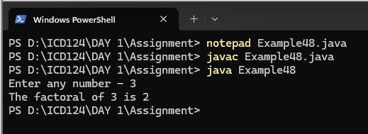

49.
import java.util.*;
class Example49{
public static void main(String args[]){
Scanner input=new Scanner(System.in);
System.out.print("Input your age - ");
int age=input.nextInt();
if(age<18){
System.out.println("age is not valid to vote");
}
else{
System.out.println("welcome to vote");
}
}
}
Output
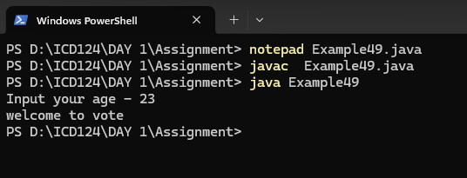

50.
public class Example50{
public static void main(String args[]){
for(int i=-5;i<6;i++){
int result =i!=0?100/i:0;
if(i!=0){
System.out.println("100/"+i+"is"+result);
}
}
}
}
Output
